The origin of the Universe

Student al UTCN, facultatea de Automatica si Calculatoare,

e-mail:
_____________________________________________________________________________________________
Abstract
The main topic approached by this paper is the origin of the Universe. It consists of a survey of the most important theory regarding this delicate matter. It provides a short examination of Universe’s history, from the moment zero until the present day, in chronological order. We investigate the key events that took place in these moments. Deficiencies and pro arguments are also discussed towards the end, alongside with the Steady State model comparison.
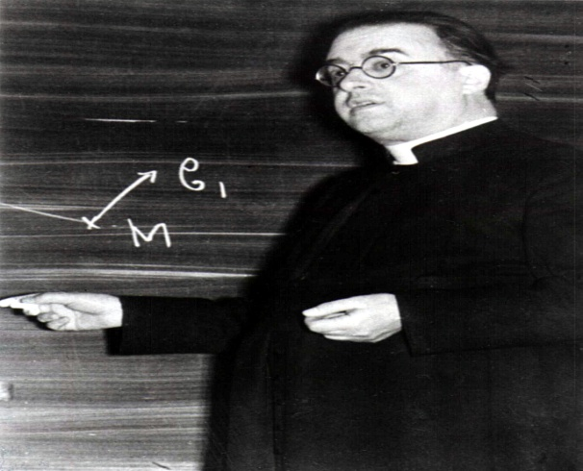
__________________________________________________________________________________________

“Do I dare
Disturb the universe?
In a minute there is time
For decisions and revisions which a minute will reverse.”
T.S. Elliot, The love song of J .Alfred Prufrock

1.Introduction
Georges Lemaitre, priest and scientist 0

As the father of the modernist literary movement has stated, there are some questions which through their simplicity and beauty put a huge burden on the shoulders of science. Thus, it is a responsibility of ethical nature for scientists and philosophers alike, to coordinate their efforts in the search for the long sought answers. However, one inquiry has since the dawn of mankind obsessed our minds:”What is the origin of the universe?”
Countless answers have been proposed to this question. While some of them have been extraordinarily creative e.g.: the Norse myth of creation about “a cow, Audhumbla, who melted ice in order to uncover the first god of the Aesir tribe, Buri.[..] His grandsons, including Odin, slew Ymir the giant and set about constructing the world from his corpse. They fashioned the oceans from his blood, the soil from his skin and muscles, vegetation from his hair, clouds from his brains, and the sky from his skull.” ¹²³ , they are admirable in their ambition and courage, but not in clarifying the issue. Physicians instead have always followed a more rigorous path, since the beginning of modern science, but until the middle part of the 20th century their efforts have been stalled by the theoretical background. However, given the discovery of Hubble’s Law and Cosmic microwave background , the theory first proposed by Georges Lemaitre is the prevailing one. He called his "hypothesis of the primeval atom" or the "Cosmic Egg" ⁴, but it is now better known as The Big Bang theory. If we simply consider that Einstein, erroneusly supporting the theory of a static Universe commented: " Vos calculs sont corrects, mais votre physique est abominable " ⁵we get a grasp on how challenging this issue was, even for the most brilliant minds. Fortunately, the world of scientists now converges in the same direction, and by falling into the framework of the Standard Model and Grand Unification Theory, the current accepted model offered us information about the Universe’s age, its evolution since the Plank Epoch⁶ and some clues about its future and birth.
Therefore, my desire has been that through this work to provide a short overview of the current state of the Big Bang theory, focusing on the chronological description of the evolution of our Universe as it is presented by the theory, comparing it with some obsolete models and presenting some difficulties that arise with it.
2.The chronology of the universe
In order to better understand the details presented in this work, I believe it is better to start with a comprehensible but not endless description of the events that took place about 13.8⁷ billion years ago and modeled the current shape of the universe, then proceed to the other subjects of my work.
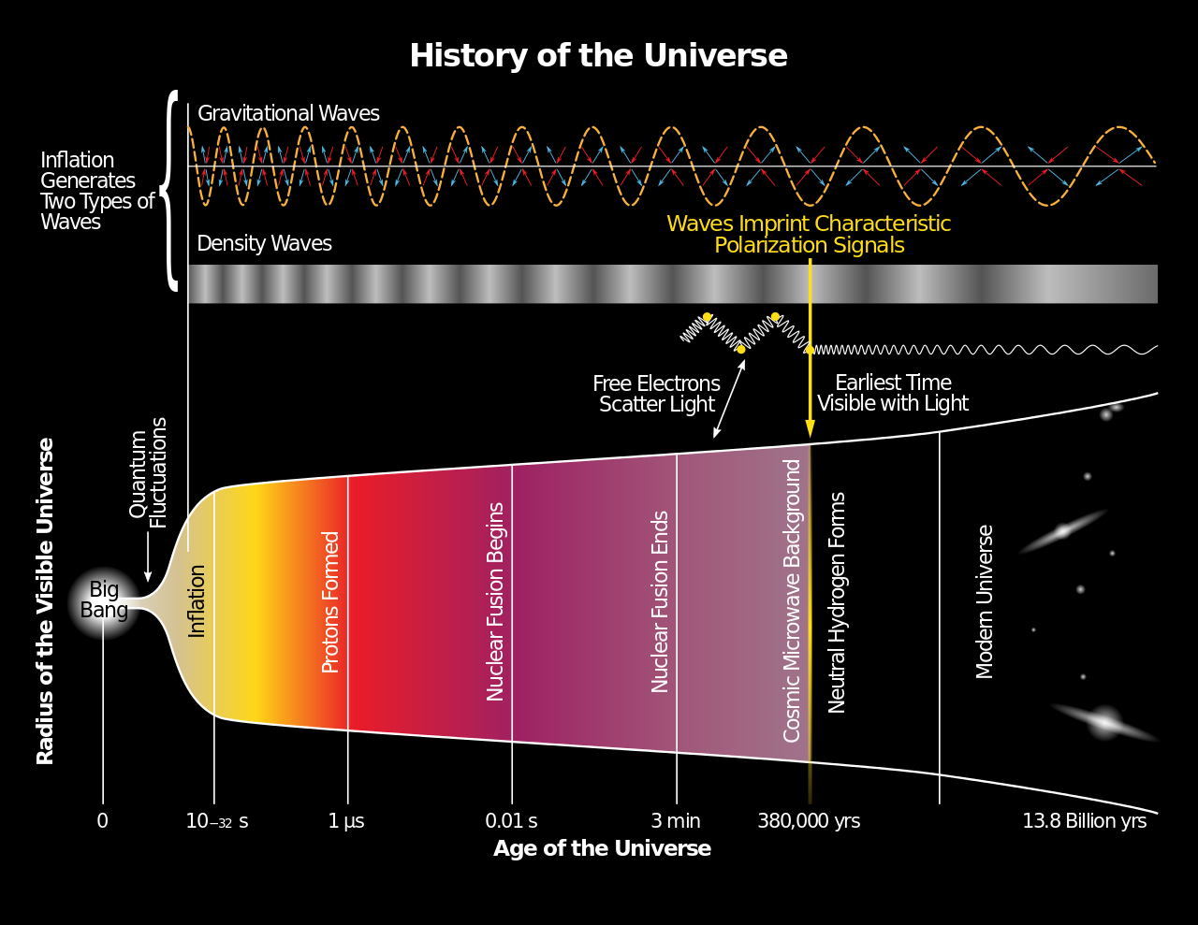
History of the Universe 1
2.1 The very beginning: up to 10^-43 seconds
Firstly, it is essential to admit that, such as in The young Edda, there is a somehow awkward ambiguity when we talk about the very begging of our Universe. Maybe it’s in the human nature to be a little bit hesitant when it comes to beginnings. What is sure to be in the human nature is our curiosity. Assuming that we know what happened from the moment zero, one could easily ask what was before that? Sadly, one could not answer that with the same coziness. In the hope of explaining the immediate moments following up of the birth of the Universe and what was before it, several hypothesizes have been launched, but most of them are purely speculative, nonetheless still worthy of being at least mentioned.

2.1.1 What was before “what”?
One proposed solution is one made by a famous physicist of our times, namely Stephen Hawking. Him, alongside James Hartle proposed the Hawking-Hartle state as a possible answer to the above question. In short, it involves a new Quantum theory, which introduces the concept of imaginary time, and moreover that space and imaginary time are finite but without boundary. Since it is without boundary, the laws of physics would be able by knowing the state in imaginary time the one in real time. The singularity at the beginning represents a an arbitrary point in spacetime, like the North Pole would on the surface of the Earth, where it began. Pretty exciting, isn’t it? Other theories include a cyclic universe model, string theory or ekpyrotic universe⁸ model.
2.1.2 The Plank epoch: 0 to 10⁻⁴³ seconds
The first period of the actual Universe is known as the Planck Epoch. At that time it is assumed that all the four forces10- were united in a single one, acting on an infinitesimal small space. However, that period is shrouded in a deep mist. Simply put, we don’t know how things worked at that time, when the temperature and the density of the Universe were inconceivably high 10^35 celsius and dimension of 10^-35 m , since we have no model describing the behavior of nature under such conditions, when gravity quantum effects were dominant. The certain thing that we know is the fact that the Universe kept expanding and cooling down.
In our current paradigm, i.e. general relativity, traditional cosmology assumes that all started from a gravitational singularity, a place of infinite gravitational field. Unfortunately, neither general relativity or quantum mechanics are able to explain the earliest moments of our universe. Even worse, it is assumed that general relativity would break down under such conditions. This means that a completely new theory, called Theory of Everything, encompassing the current ones would be needed for a complete description.
2.2 The grand unification epoch 10⁻⁴³ to 10⁻³⁶ seconds ⁹
The next period is one of which we know sensibly more things, namely The grand unification epoch. It derives its name from the Grand unification theory, a theory which embodies the gauge forces, theory which is believed to describe this period of time. In this period, the temperature dropped under a threshold value 10^27 K and gravitation separated from the other three fundamental forces. Moreover, the universe kept expanding and at the end of the epoch it increased its magnitude from that of a quark to the one of a proton. At the end of this period of time, several key events took place.
2.3 The Electroweak period 10⁻³⁶ (or the end of inflation) and 10⁻³² safter the Big Bang to 10⁻¹² seconds ⁹
The electroweak epoch is the period in the evolution of the early universe when the temperature of the universe was high enough to merge electromagnetism and the weak interaction into a single electroweak interaction The electroweak epoch began when the strong force separated from the electroweak interaction. Some cosmologists place this event at the start of the inflationary epoch, approximately 10⁻³⁶ seconds after the Big Bang. Others place it at approximately 10⁻³² seconds after the Big Bang ¹⁰when the potential energy of the inflaton field that had driven the inflation of the universe during the inflationary epoch was released, filling the universe with a dense, hot quark-gluon plasma.
Luckily for us, this is the first period of time of which we know for sure what happened. For instance, the Universe became slightly more livelier as W and Z Bosons were created (particles which intermediate the weak interaction) along with the long sought Higgs Boson(the particle whose field confers mass to particles). At the end of this period, the electroweak forces break away from each other, giving us another premiere: having all the four forces independent from each other, the first masses given by the Higgs field and of course, photons.
2.3.1 Inflationary period –unknown duration
Remember that I said that we know for sure what happened between 10⁻³⁶ and 10⁻¹² after the Big Bang? Well, I was a bit too optimist since recently, in the last two decades, a new distinct interval of time has been advanced, namely the Inflationary period. Even though the evidence for it is sparse¹¹, it is held in high regard, since it accounts for the isotropy of the universe and its local flatness, key characteristics in our model. It consisted of a rapid, exponential expansion of the universe, up to the size of a grapefruit, at speeds higher than that of light. During this expansion, which can be compared to the blowing of a balloon, the temperature dropped by some orders of magnitude, in order to raise again, in a process called reheating.
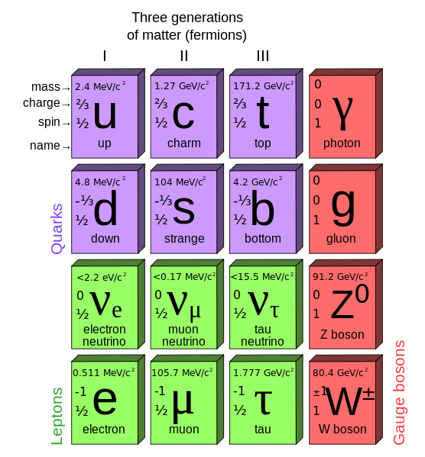
As it was said before, this process gives a somewhat satisfying description of the isotropy of the universe. Namely, the Universe seems to be the same regardless of what direction we are looking into. This is presumed to be the effect of a rapid expansion of the very early Universe, which was intermediated by a field named Inflaton. Since this expansion was extremely quick in a short amount of time, the elementary particles existing at that time were spread very thinly across it’s volume, which increased by 10^78 times.
Standard Model Elementary particles
Standard Model Elementary Particles 2
2.4 The quark epoch 10⁻¹² to 10⁻⁶ seconds
So here we are, at the beginning of the early Universe (we know that the previous periods of time formed the very early Universe), which started with the quark epoch. What is interesting about this epoch it is that the Universe became filled with an extremely hot quark-gluon plasma. This state of matter resembles partially to the ordinary plasma, but since there were no electrons nor atoms, it is just an incredibly dense (like, the densest matter known, denser even than a neutron star ¹²), where quarks¹³ are so energized that the gluons¹⁴ cannot bind them into hadrons. However we can consider this “cosmic soup” to be the beginning of matter, which can be first consistently observed in the next stage, the hadron epoch.
2.5 The hadron epoch 10⁻⁶ to 1 second after the Big Bang
The next period of time in the evolution of the Universe is known as the hadron epoch, epoch in which the Universe has cooled down enough to soothe the quarks. This epoch also presents one of the greatest mysteries of current science. There are no atoms yet, no electrons or even nuclei. Only Hadrons, which are made up of protons and neutrons, are forming. However, because almost all physical processes appear to be symmetrical in nature, particles of antimatter also form. Equal amounts of antimatter should annihilate matter as it appears. But it didn't, as evidenced by everything around us today.
The universe now operates under the regime dictated by the four fundamental forces, at a temperature of about 10¹³K. Gluons can now easily bind the quarks into hadrons, namely baryons(made up of 3 quarks) like protons and neutrons and mesons(made up of one quark and one antiquark, the twin brother made of antimatter of a quark). However, the numbers aren’t equal between protons and neutrons, since protons are easier to create, we will have a ratio of about 7:1! The opposing pairs of matter and antimatter annihilate themselves, releasing a lot of energy as a result, but a small percent of matter is left over, such that the Good always prevails. The remaining quarks will be the seeds for the protons and neutrons that will populate our Universe.
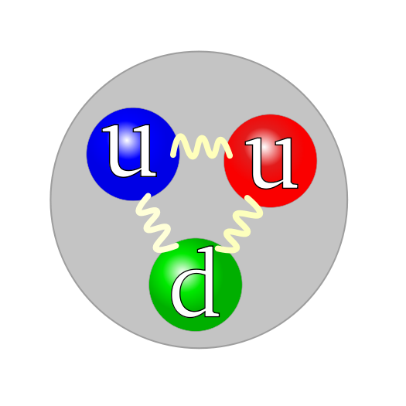
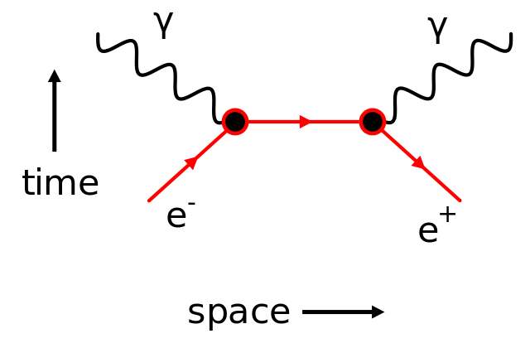

Feynman diagram 4
Quark structure of a proton 3

2.6 The lepton epoch 1 second-10 seconds
The start of the lepton epoch is marked by the end of the formation of opposite pairs of hadrons. What is left in the Universe, which is 1000 times larger that our Solar System, is a residue of hadrons and a dominating amount of leptons, namely electron and their pairs, positrons plus gamma photons. Naturally, the pairs which were still created since the high energy allowed it, kept annihilating each other, releasing photons, as the Feynman diagram shows. By approaching the end of this epoch, the temperature drops to a point which doesn’t allow the creation of more lepton-antilepton pairs. In the end, a small residue of leptons remained, and the photons were this time the most popular particle in the Universe, the photon epoch. The Universe is 10 seconds old at this point, but its still lacking in atoms.
2.7 The photon epoch 10 seconds to 380.000 years
The photon epoch is one of the most important ones, since it involves the creation of simple nuclei in a process called Big Bang Nucleosynthesis. Currently, the Universe is riddled with photons, which bounce of particles after colliding with them for uncountable times. Therefore, this matter behaves as a fluid called photon baryon fluid, which consist of matter and radiation.
2.7.1 Nucleosynthesis
As stated above, nucleosynthesis is the process in which atoms are finally created. However, only the smaller ones are created: helium as the isotope (⁴He), along with small amounts of the hydrogen isotope deuterium (²H or D), the helium isotope helium-3 (³He), and a very small amount of the lithium isotope lithium-7 (⁷Li). In addition to these stable nuclei, two unstable or radioactive isotopes were also produced; but these unstable isotopes later decayed into ³He and ⁷Li, as above. What is more, this process was widespread, encompassing the whole universe¹⁵, filling it with more complex matter than before.
At about twenty minutes old, the temperature is too low to allow the fusion of any more nuclei. At this point the universe contains about 75% H1, 25% Helium-4 and about 0.01% deuterium as well as trace amounts of lithium and beryllium nuclei (by mass). The universe will continue to expand and cool for another 379,000 years before the first stable atoms begin to appear. Only then will free electrons will be of low enough energy to be captured by positively charged nuclei, aspect which will be explored in our next chapter.
2.8 The Decoupling epoch 377 000 years after the Big Bang ¹⁶
This period is another full of surprises. For instance, we have the first picture from the childhood of our universe, in the form of the cosmic background radiation. Now, the photons are no longer colliding and therefore are free to travel in form of visible light. They kept traveling until today, almost 14 billion years later, even if with reduced energy. This is caused by the redshift of their wavelength, reducing their temperature and increasing their wavelength, which was spotted in the microwave region.
The universe it’s on its way to become the star vastness it is today. It is now about one thousandth of its present size and at about 4000K hot. Below this temperature, which is 13.6 eV, the ionization temperature of H, the atoms permanently capture their electrons and become neutral instead of ionized.
2.9 The Dark ages 3 up to 500 mil years(150 mil)
In this period, the Universe has become gradually transparent as the photons spread. All the same, the only source of light became dimmer, leaving us with little information about this period, subsequently named The Dark age of the universe. In this period, the first stars began to form(marking its end), however only isolated. Gravitation is now taking over, becoming the predominant force, while molecular gas clouds of H₂ are being formed for the first time.
The current model of the universe suggests that the first stars were formed before the 150 million year birthday of our universe, however it is hard to pinpoint exactly when. The universe stands now at about 2000-3000K, which is “colder” than our sun. Another interesting concept shows up in this period, the dark matter. It has not been detected directly, but it is hold responsible for more than 80% of the mass in the universe. Without it, the epoch of galaxy formation would occur much later in the Universe than it was observed. Eventually, at some random location, a fluctuation in the density field made up of gas and dark matter would have initiated the forming of the first star. The gas cloud would have collapsed to form a central core of compressed hydrogen gas. Finally, it will become hot enough to start fusing hydrogen into helium, and thus, the star was born. This marks the end of our early universe and the beginning of the current age of the universe.
3.0 The Stelliferous Era 150million years up to our days and beyond(100trilion years)
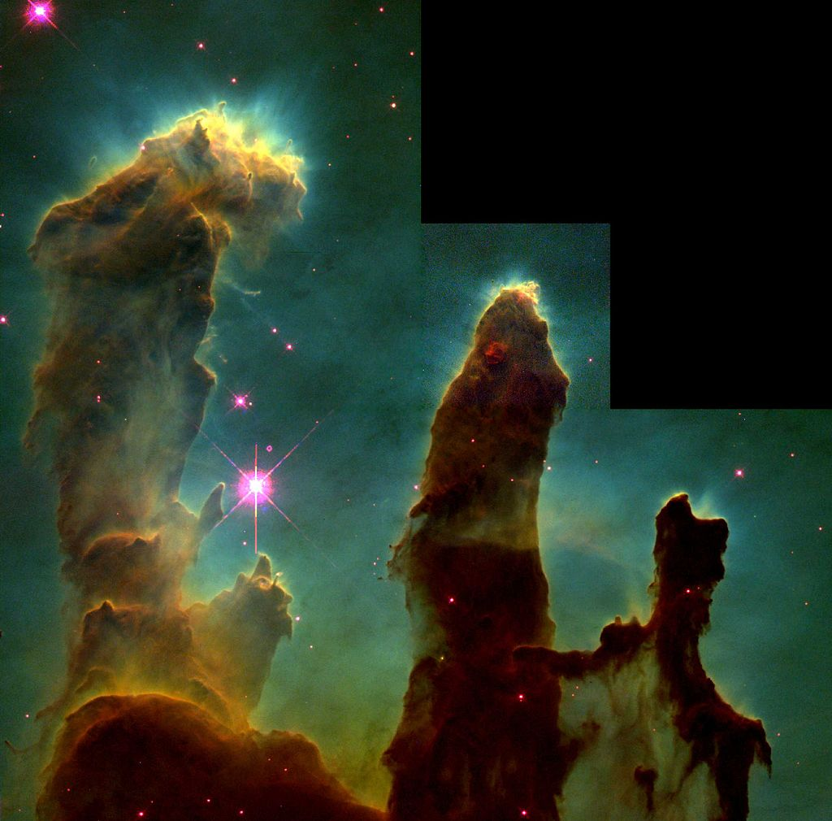
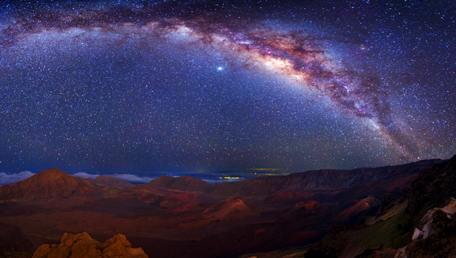
Stelliferous means filled with stars. And that it’s what our Universe is like. A simple glance on the skies reveals us countless stars and even arms of our galaxy, the Milky Way. This era began when the first stars started to form, being followed by galaxies, blackholes, superclusters¹⁷ and all the other spectacular structures which can be seen today.
Pillars of Creation 5
The Milky Way seen from Earth 6
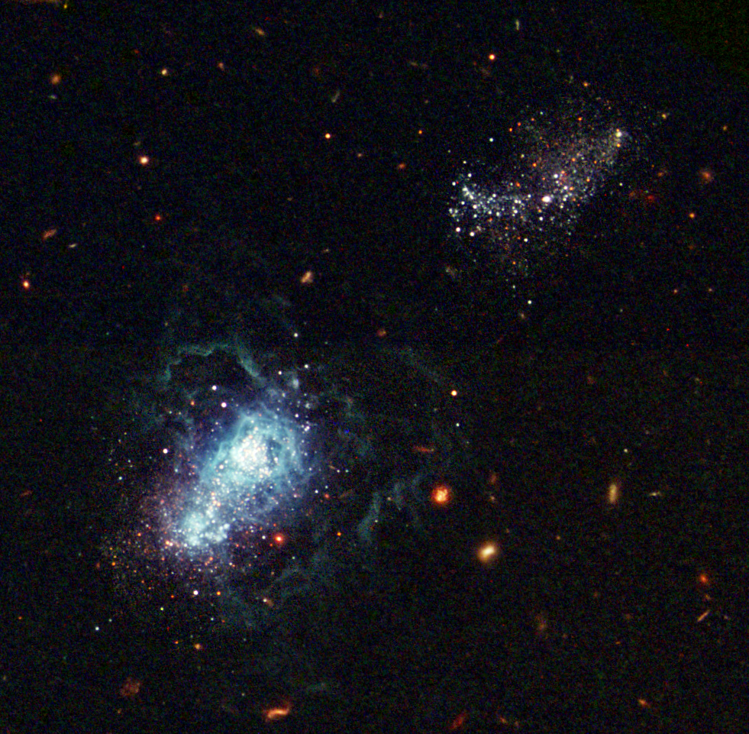
In physical cosmology, structure formation refers to the formation of galaxies, galaxy clusters and larger structures from small early density fluctuations. The first stars, known as Population III stars were hot massive stars containing no heavy elements. They would have burned very intensely, emitting intense ultraviolet light, which would have ionized the neutral hydrogen gas around them. They would have burned out rapidly, in the span of a few million years, ending their brief lives in intense supernovae blowing new heavier elements such as carbon, silicon, oxygen and iron into other collapsing gas clouds, seeding those forming stars with these new elements. Therefore, younger stars have a higher proportion of heavy elements, our Sun included. It is suspected that some Population III stars turned into blackholes, which are found at the center of most galaxies. They contain star systems, star clusters and interstellar gas. It is the interstellar gas that new stars are made from. Our galaxy, shown below, is a fairly old galaxy, about 13.2 billion years old. Galaxies are believed to be form by swallowing smaller ones, until the mass is high enough that the dark matter stays on the outside of the galaxy and the gas cloud contracts and starts spinning, until the result is very thin, very rapidly rotating disk
Galaxy being formed 7
Population II stars are the oldest extant stars in the universe. They contain a small proportion of elements heavier than hydrogen and helium, such as oxygen, silicon and neon. Population II stars are believed to contribute all the elements to the universe, except some of the very heavy unstable ones.
Our Sun is a relatively metal-rich intermediate Population I star. Population I stars, like the Sun, are common in the spiral arms of the Milky Way. The youngest stars of all are extreme Population I stars. Population I stars are more likely to have planets orbiting them because planets, especially rocky ones, are formed from the accretion of heavy metal-rich elements.
In another 8,5 billion years from the beginning of this era, when the universe is about 9,5 billion years old, our home, the Earth, will begin to form. Four billion years ago, abiogenesis¹⁸ would have begun, and after a long and treacherous road, homo sapiens sapiens made its appearance, and started asking questions about the origin of the Universe.

3.The Steady State model
The Steady State theory is in cosmology a generally discredited expanding universe model alternative to the Big Bang Theory. What is different is that in the Steady State view, matter is continuously formed as the universe expands, thus adhering to the perfect cosmological principle (the principle that the observable universe is basically the same in any time as well as any place). While it has enjoyed some popularity in the mid-20th century, it is now considered obsolete, as the evidence points to a Universe with finite age, which is predicted by the Big Bang theory.¹⁹
Cosmological expansion has been discovered thanks to the efforts made by Edwin Hubble. Furthermore, theoretical calculations showed that a static universe was impossible under the conditions of the General Relativity. Until here, the Steady State model is in harmony with what we already know. The problem is that this theory asserts that although the universe is expanding, it nevertheless does not change its appearance over time; i.e. it has no beginning and no end. The discovery of cosmic microwave background marked “the final nail in the coffin of the steady-state theory.”²⁰ Therefore, the theory strongly supported by Bondi, Gold, and Hoyle in 1948 was forgiven.

4. Evidence for Big Bang and problematic points
As any scientific theory, the Big Bang model requires some observational evidence in order to be credible. As Carl Sagan said “extraordinary claims require extraordinary evidence”, there ought to be some convincing arguments in favor of this model. Fortunately, we have some good evidence to support this claim, but in the same measure we have some difficulties which are currently explored by the world of science. Whilst some of them are easier to solve, some of them may remain forever a mistery. Among these we have: baryon asymmetry, dark energy, dark matter and the horizon problem
4.1 Evidence for
The most important pieces of evidence for our model are Hubble’s law and the expansion of space and the Cosmic microwave background radiation. Besides those, our model predicts with a high degree of accuracy the abundance of primordial elements.
4.1.1 Hubble’s law and the expansion of space
Observations of distant galaxies and quasars show that these objects are redshifted. These redshifts are uniformly isotropic, distributed evenly among the observed objects in all directions. If the redshift is interpreted as a Doppler shift, the recessional velocity of the object can be calculated. What is more, for some galaxies, it is possible even to estimate distances. When the recessional velocities are plotted against these distances, a linear relationship known as Hubble's law is observed:
v = H₀D ²¹
v is the recessional velocity of the galaxy or other distant object, D is the comoving distance to the object, and H₀ is Hubble's constant, measured to be 70.4+1.3−1.4 km/s/Mpc by the WMAP probe²². This agrees with the results of A Friedmann from 1922 which says that the universe is expanding uniformly everywhere.
4.1.2 Cosmic microwave background radiation
Another great discovery was the one made by Arno Penzias and Robert Wilson in 1965 serendipitously, since they mistaken its cause for pigeon nests. Their discovery provided substantial confirmation of the big-bang predictions made decades before. Through the 1970s the radiation was found to be approximately consistent with a black body spectrum in all directions; this spectrum has been redshifted by the expansion of the universe, and today corresponds to approximately 2.725 K. This tipped the balance of evidence in favor of the Big Bang model, and Penzias and Wilson were awarded a Nobel Prize in 1978.
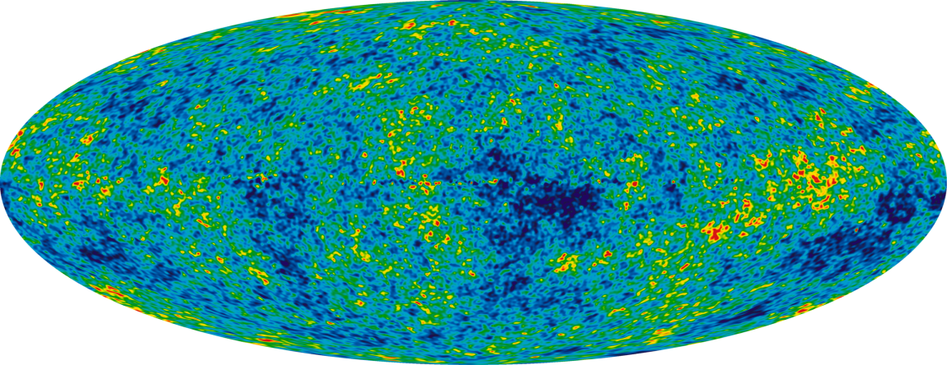
Cosmic microwave background 8
5.Conclusions
In this final chapter I would like to express my final thoughts regarding this vast subject and the reasoning behind my style of writing. Firstly, although I’ve written a big deal, there are several areas of interest which could be discussed here, such as the string theory and how it merges with the origin of the Universe, more models which aim/aimed to describe this, or some thoughts about its final state.
As far as the writing style is concerned, I’ve opted for this more relaxed and casual writing since I do not have enough background knowledge to dwell deep in the matter (and I doubt that more than 0.1% of world’s population can do it). Thus, I think that a text filled with complicate integrals and endless equations would have discouraged the reader and would have made the writer’s job a nightmare since he would be overwhelmed by its task. Finally, I also think that this style of writing simply better fits my writer ego, by trying to incorporate quotes and references to other domains.
Nonetheless, I consider that this matter is one of great sensibility and challenges. However, I believe that we are on the right track, and along with new advancements in technology e.g.: LHC development, we will be one step closer to uncovering the remaining mysteries. But the one thing which amazes me is that “The cosmos is within us. We are made of star-stuff. We are a way for the universe to know itself.”- Carl Sagan

7.Appendices
- The Poetic Edda. Völuspá.
- The Poetic Edda. Vafþrúðnismál.
- The Poetic Edda. Grímnismál.
- Lemaître, G. (1931). "The Beginning of the World from the Point of View of Quantum Theory".
- "Your calculations are correct, but your physics is atrocious." Deprit, A. (1984). "Monsignor Georges Lemaître". In A. Barger (ed). The Big Bang and Georges Lemaître. Reidel. p. 370.
- between 0 and 10⁻⁴³ seconds which is 1 Planck time
- Planck Collaboration (2015). "Planck 2015 results. XIII. Cosmological parameters (See Table 4 on page 31 of pfd)."
- according to the ekpyrotic theory, the the big bang was actually a big bounce, a transition from a previous epoch of contraction to the present epoch of expansion. The key events that shaped our universe occurred before the bounce, and, in a cyclic version, the universe bounces at regular intervals. Steinhardt, P. J.; Turok, N. (2002-04-25). "A Cyclic Model of the Universe"
- Ryden B: "Introduction to Cosmology", pg. 196 Addison-Wesley 2003
- Lecture 13: History of the Very Early Universe, Dr. Balša Terzić, Northern Illinois Center for Accelerator and Detector Development
- Amos, Jonathan (June 19, 2014). "Cosmic inflation: Confidence lowered for Big Bang signal".
- A neutron star is a type of compact star that can result from the gravitational collapse of a massive star after a supernova. Neutron stars are the densest and smallest stars known to exist in the Universe;
- A quark is an elementary particle and a fundamental constituent of matter
- Gluons are elementary particles that act as the exchange particles for the strong force between quarks
- J. Beringer et al. (Particle Data Group), "Big-Bang cosmology”
- Hinshaw, G.; et al. (2009). "Five-Year Wilkinson Microwave Anisotropy Probe (WMAP) Observations: Data Processing, Sky Maps, and Basic Results"
- Superclusters are large groups of smaller galaxy clusters or galaxy groups and are among the largest known structures of the cosmos.
- Abiogenesis is the natural process of life arising from non-living matter, such as simple organic compounds.
- Kragh, Helge (1999). Cosmology and Controversy: The Historical Development of Two Theories of the Universe
- quote by Stephen Hawking
- Hubble, E. (1929). "A Relation Between Distance and Radial Velocity Among Extra-Galactic Nebulae"
- Jarosik, N.; et al. (WMAP Collaboration) (2011). "Seven-Year Wilkinson Microwave Anisotropy Probe (WMAP) Observations: Sky Maps, Systematic Errors, and Basic Results"

